Session Explanations – AWS Student Builder Group (SBG) × DBIT

Based on our previous discussions about AWS Student Builder Group at DBIT, the AIML Department, and HEXAVERSE CLOUD FEST ’26, here is structured explanatory content for the four session titles.

The explanations are designed for your workshop agenda, presentation slides, speaker notes, or website content. They connect the introductory sessions to the broader goal of helping students explore AWS, cloud computing, and hands-on AI/ML development.

1. Welcome & Intro to AWS SBG DBIT



Overview

This session introduces students to the AWS Student Builder Group (SBG) – DBIT, its community, its purpose, and the learning opportunities it creates for students interested in cloud computing, artificial intelligence, machine learning, and emerging technologies.

It establishes the foundation for the workshop by helping participants understand who is organizing the event, why the community exists, and how they can become active contributors to the campus technology ecosystem.

Key Points to Cover

Introduction to AWS Student Builder Group – DBIT.

The collaboration between AWS SBG and the Artificial Intelligence and Machine Learning Department.

The community's purpose: encouraging students to learn, build, experiment, and share knowledge.

Opportunities to participate in workshops, technical events, peer learning, and cloud-focused activities.

How AWS skills can support academic projects, hackathons, internships, and future career opportunities.

Introduction to the workshop journey and what participants can expect over the two days.

Suggested Explanation for Students

Welcome to HEXAVERSE CLOUD FEST ’26, brought to you by the AWS Student Builder Group – DBIT in collaboration with the Artificial Intelligence and Machine Learning Department.

AWS Student Builder Group is a student-driven community focused on creating opportunities to explore cloud technologies, develop practical skills, and build innovative solutions. Through workshops, technical sessions, and collaborative learning, we aim to make emerging technologies more accessible to every student.

This workshop is an opportunity to move beyond theoretical knowledge and begin exploring how cloud platforms like AWS can turn ideas into working solutions.

Expected Outcome

Students should understand the role of AWS SBG DBIT, feel welcomed into the community, and recognize the learning and collaboration opportunities available to them.

2. Icebreaker & Settle-In

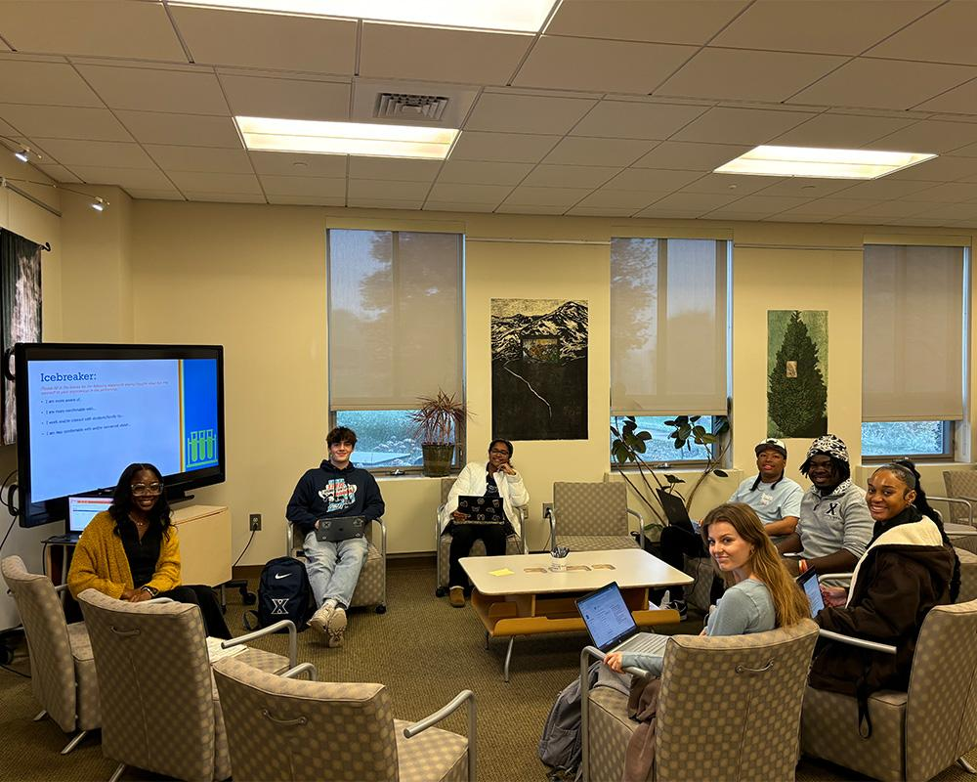

Overview

The Icebreaker & Settle-In session helps participants become comfortable in the workshop environment, interact with fellow students, and transition from their everyday academic routine into an engaging, hands-on learning experience.

Since participants may come from different classes, backgrounds, and technical skill levels, this session creates an inclusive atmosphere where everyone feels encouraged to participate.

Key Points to Cover

Welcoming participants and helping them settle into the venue.

Introducing fellow participants and workshop facilitators.

Understanding students' backgrounds and familiarity with AWS or cloud computing.

Encouraging interaction, teamwork, and open communication.

Setting expectations for participation and hands-on activities.

Creating an environment where students feel comfortable asking questions.

Suggested Activity

Cloud Connection Icebreaker

Ask participants to briefly introduce themselves by sharing:

Name and department.

Current technical interests.

Whether they have used AWS or any cloud platform before.

One thing they hope to build or learn during the workshop.

You can also ask:

"If you could build one technology solution to solve a problem on your campus, what would it be?"

This connects the icebreaker directly to the workshop's innovation and cloud-building theme.

Suggested Explanation for Students

Before we begin exploring cloud computing, let's take a moment to get to know the people around us. Technology is not just about tools and platforms; it is also about collaboration, creativity, and sharing ideas.

Whether you are completely new to AWS or have already worked on cloud projects, this workshop is designed to be a space where everyone can learn, experiment, and grow together.

Expected Outcome

Participants become comfortable, engaged, and ready to collaborate during the technical sessions.

3. History of Cloud & AWS





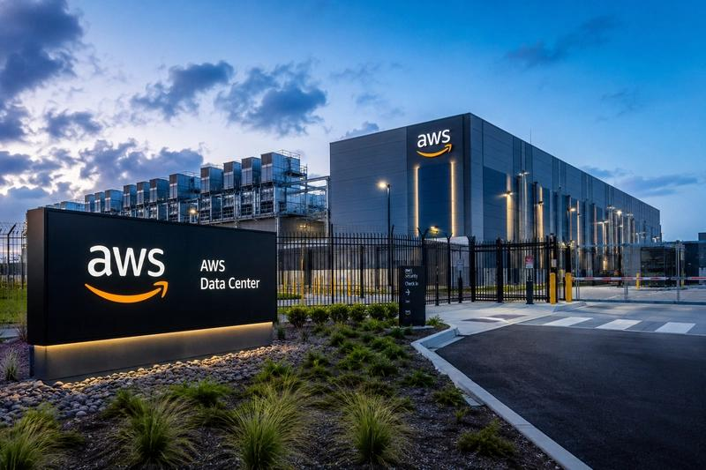

6

Overview

This session introduces the evolution of computing infrastructure—from traditional on-premises servers to modern cloud computing—and explains how Amazon Web Services (AWS) emerged as a major cloud platform.

The objective is to help students understand why cloud computing became necessary, what problems it solves, and how it enables developers to build and scale applications without owning physical infrastructure.

Part 1: Before Cloud Computing

Traditionally, organizations had to purchase and maintain their own physical servers, networking equipment, storage systems, and data centers.

This approach required:

Significant upfront investment in hardware.

Dedicated teams for infrastructure maintenance.

Physical space, electricity, and cooling.

Advance planning for future computing requirements.

Additional hardware whenever demand increased.

For example, if a college wanted to host its own student portal, it would need to purchase servers and manage the infrastructure itself.

Part 2: The Challenges of Traditional Infrastructure



Traditional infrastructure created several challenges:
Challenge | Explanation
High initial cost | Hardware and infrastructure require significant investment.
Limited scalability | Increasing capacity often requires purchasing additional servers.
Maintenance overhead | Organizations must manage hardware, networking, and software infrastructure.
Resource wastage | Servers may remain underutilized during periods of low demand.
Slow deployment | Setting up infrastructure can take considerable time.

Part 3: The Emergence of Cloud Computing

Cloud computing introduced a different approach: instead of purchasing and maintaining all infrastructure, organizations can access computing resources over the internet from cloud providers.

Cloud computing is the on-demand delivery of IT resources such as computing power, storage, and databases, typically with usage-based pricing.

This allows businesses and developers to provision resources when needed, scale according to demand, and experiment without large upfront infrastructure investments.

Amazon News

+1

Simple Example

Imagine you are building a college event registration website.

Traditional approach:

You purchase a server, configure it, maintain it, and estimate how much traffic the website might receive.

Cloud approach:

You use cloud services to host the application, store registration data, and scale resources according to demand.

This makes it easier to start small and expand as the project grows.

Part 4: The Birth of AWS



Amazon Web Services emerged from Amazon's experience building and operating large-scale technology infrastructure for its e-commerce business.

AWS began offering infrastructure services in 2006, helping organizations access computing resources through web-based services instead of building everything themselves.

Amazon Web Services

+1

AWS Timeline

From Infrastructure to Innovation

Before 2006 — Traditional IT
Organizations primarily relied on physical infrastructure and self-managed data centers.

2006 — AWS Launches
AWS begins providing on-demand infrastructure services to organizations.
Amazon News
+1

Cloud Expansion
Cloud services grow across computing, storage, databases, networking, analytics, and application development.

Modern Cloud & AI
Cloud platforms support advanced workloads, including machine learning, generative AI, and intelligent applications.

Part 5: Understanding AWS Through Real Services

Introduce students to a few fundamental AWS services:

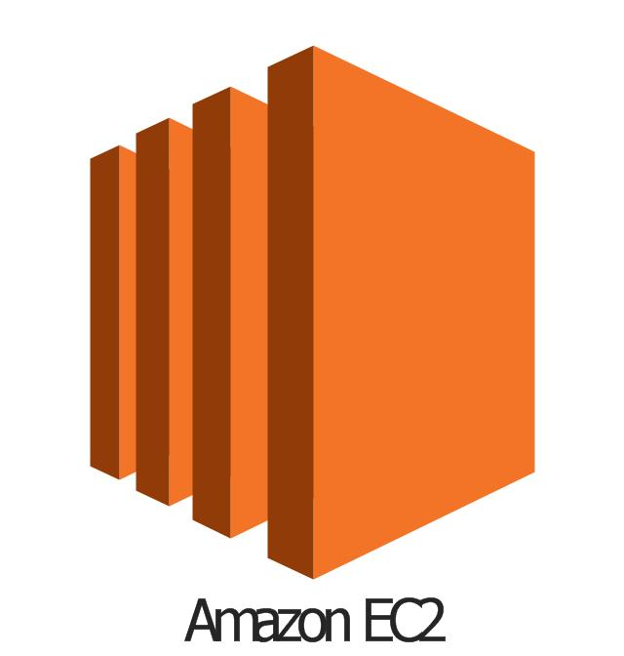

Amazon EC2

Provides virtual computing capacity in the cloud, allowing users to run applications without owning physical servers.

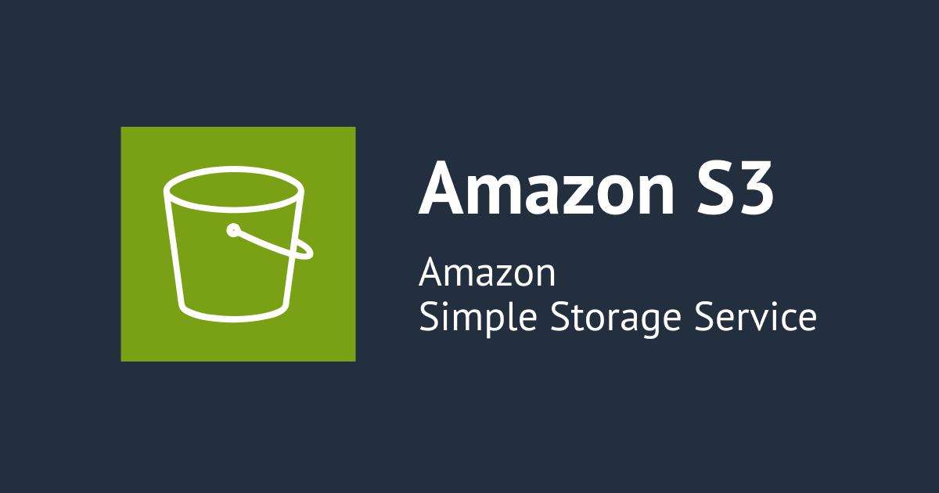

Amazon S3

Stores and retrieves data such as files, images, documents, and application assets.



AWS Lambda

Runs code in response to events without requiring developers to manage servers directly.



Amazon Bedrock

Provides access to foundation models and tools for building generative AI applications.

These services illustrate how AWS provides different building blocks for developing modern applications.

AWS Documentation

+1

Suggested Explanation for Students

Before cloud computing, building an application often meant investing in physical servers, configuring infrastructure, and maintaining everything ourselves.

Cloud computing changed this model by making computing resources available on demand through the internet.

AWS took this idea further by providing a broad collection of services that developers can use to build applications, store data, run code, and experiment with emerging technologies.

As AIML students, understanding cloud computing is important because modern AI and machine learning applications often require scalable computing, data storage, deployment infrastructure, and access to specialized services.

Interactive Question

Ask students:

"If you had to launch a website for your college event and expected 10 visitors today but 10,000 visitors during the final registration deadline, how would cloud computing help you manage that change?"

This connects the historical evolution of cloud computing to a real-world student use case.

Expected Outcome

Students understand the limitations of traditional infrastructure, the purpose of cloud computing, the origins of AWS, and the role of cloud services in modern software and AI/ML development.

4. AWS Builder Center Resource

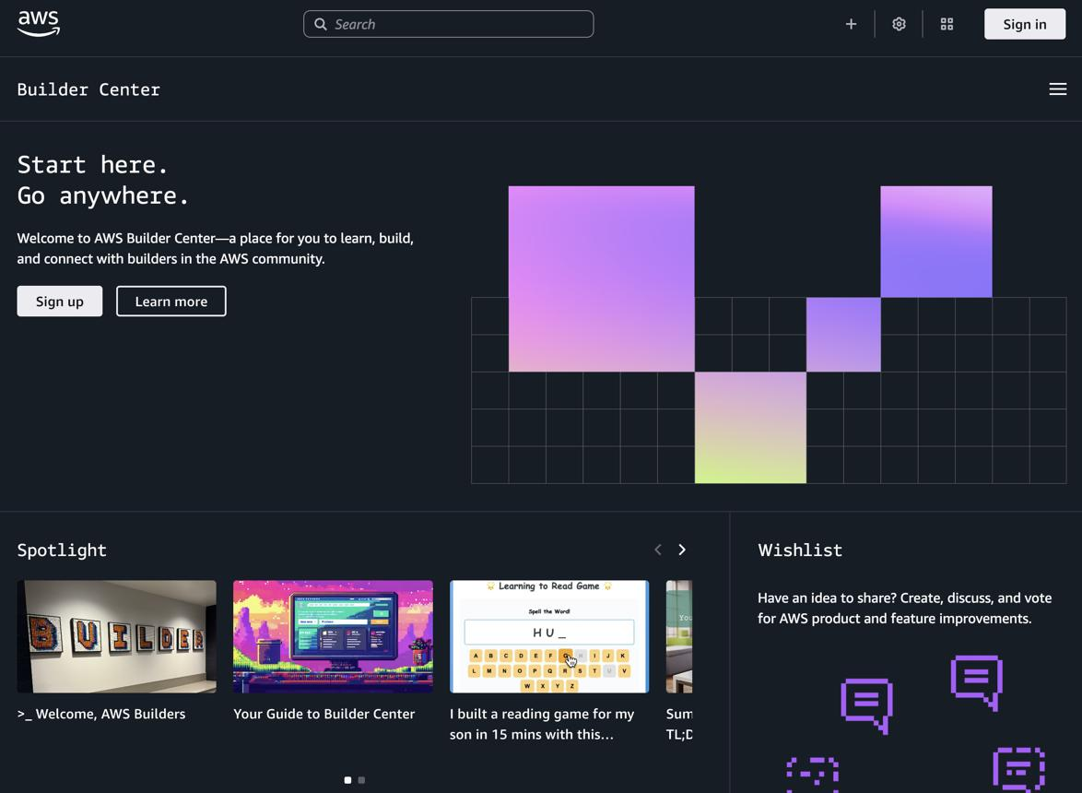

Overview

This session introduces AWS Builder Center, the official online home for builders in the AWS community.

It helps students discover how to continue learning beyond the workshop through technical resources, hands-on workshops, community discussions, events, and learning opportunities.

AWS Builder Center brings together community engagement, learning resources, and tools for people building on AWS.

AWS

+1

AWS Builder Center

Official Resource: builder.aws.com

A place to connect, learn, build, and engage with the AWS builder community.

What Is AWS Builder Center?

AWS Builder Center is a community and learning platform where builders can:

Discover technical content and learning resources.

Connect with fellow AWS builders.

Explore hands-on workshops and tutorials.

Find community events and groups.

Access learning opportunities through AWS Skill Builder.

Share knowledge, ideas, and technical experiences.
AWS News Blog
+1

Key Resources to Explore

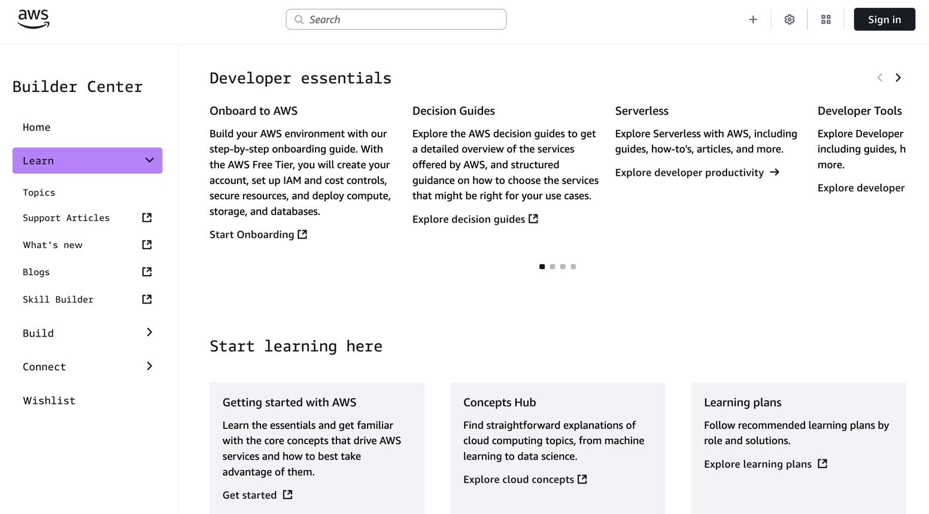

1. Learn

Skill Development

Explore training resources, learning paths, workshops, and educational content to improve AWS knowledge.

Useful for beginners who want structured learning after the workshop.

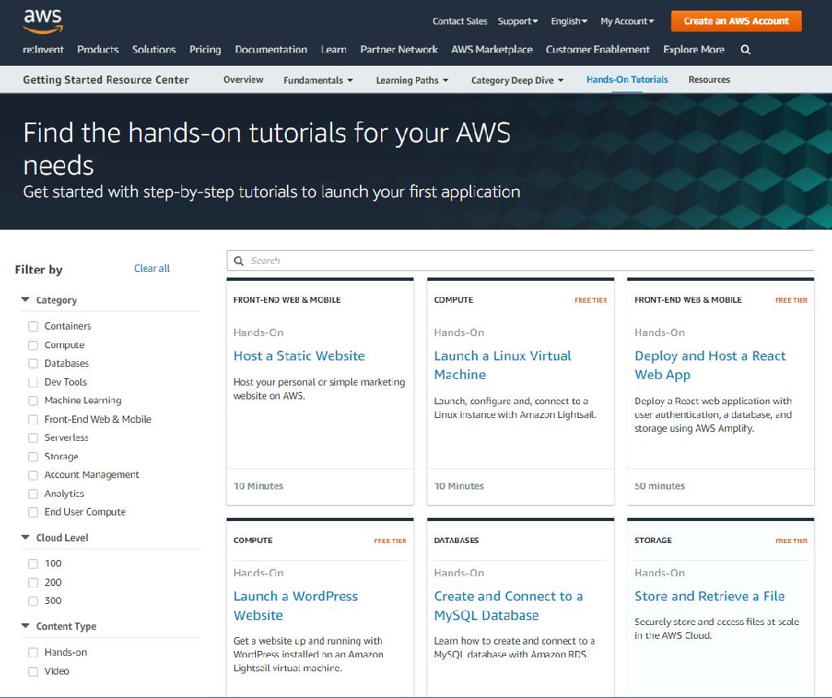

2. Build

Hands-On Practice

Discover AWS tutorials, workshops, and practical experiences that help students move from theory to implementation.

Ideal for learning by building real cloud projects.

3. Community

Connect

Engage with fellow builders, discover communities, follow technical contributors, and participate in discussions.

Helps students learn from others and build professional connections.

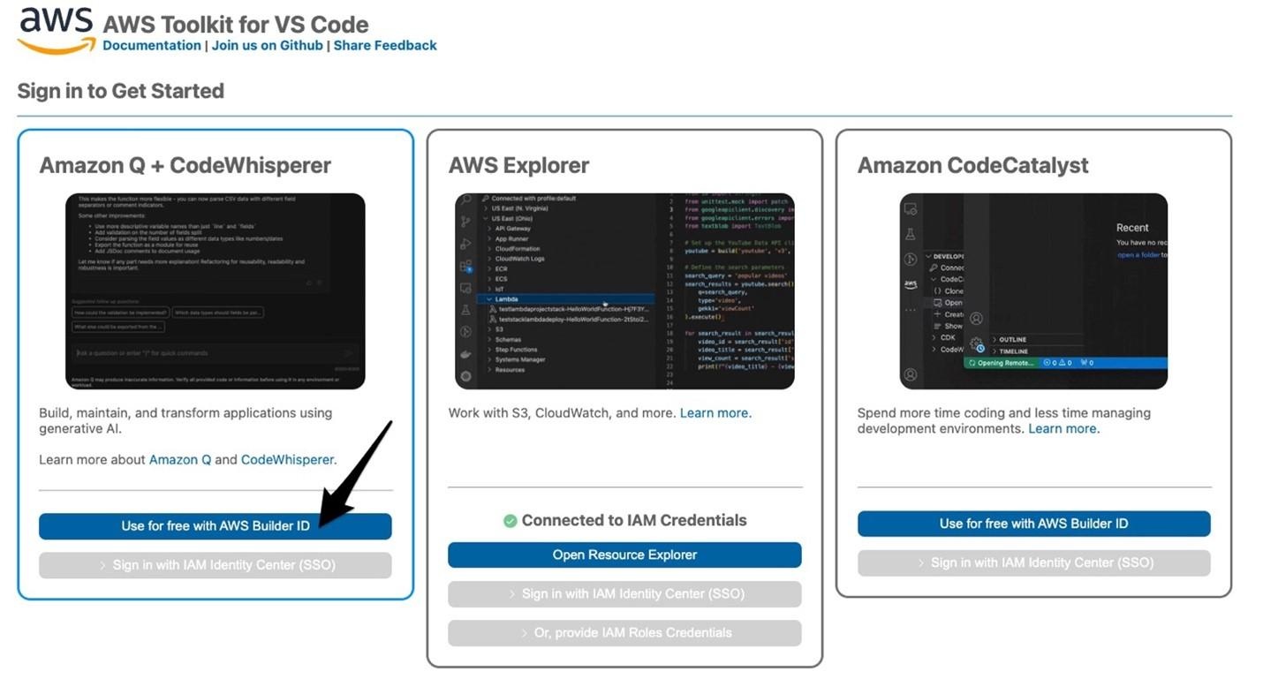

4. Toolbox

Developer Resources

Explore tools, programming resources, and technologies that support building applications on AWS.

These resource areas reflect the learning, building, community, and tooling experiences highlighted by AWS Builder Center.

AWS News Blog

+1

Live Demonstration: Getting Started with AWS Builder Center

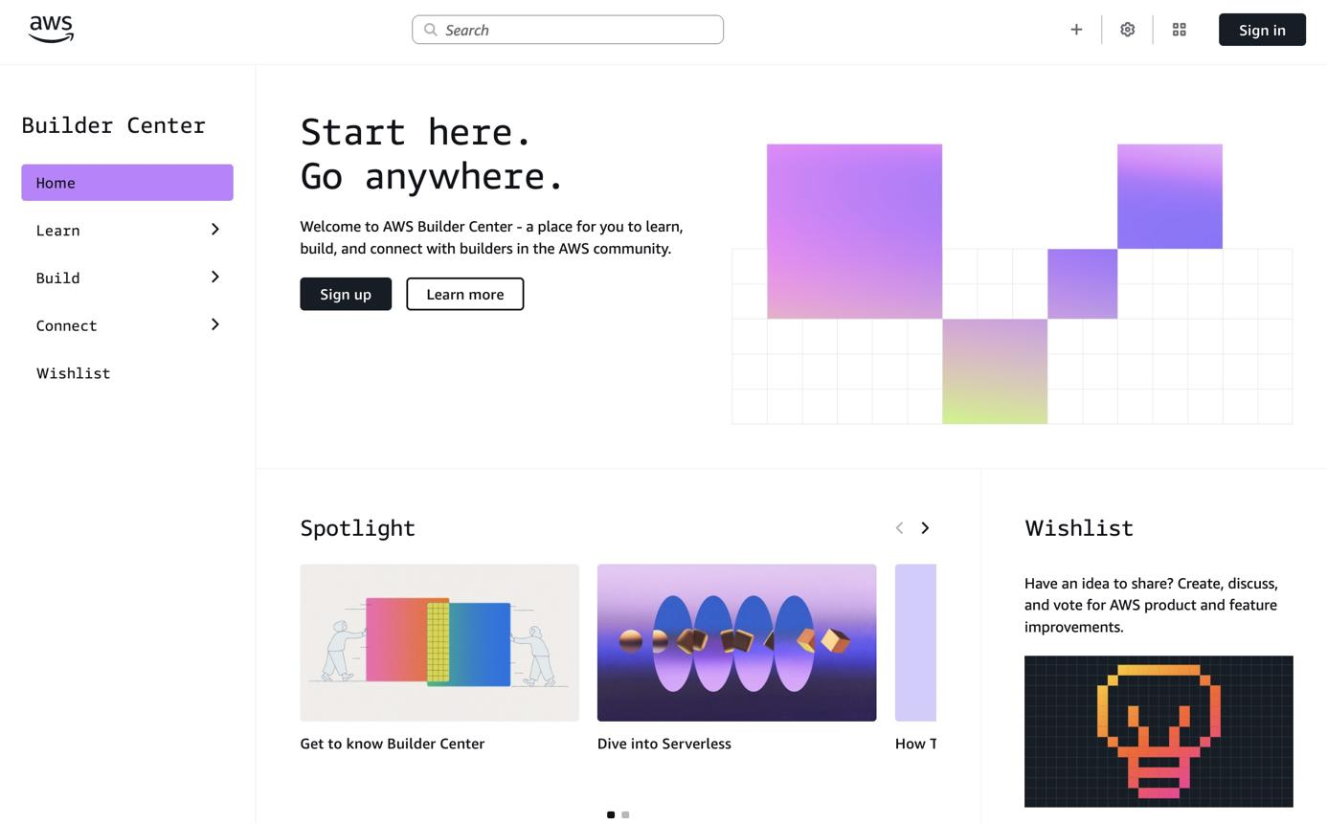

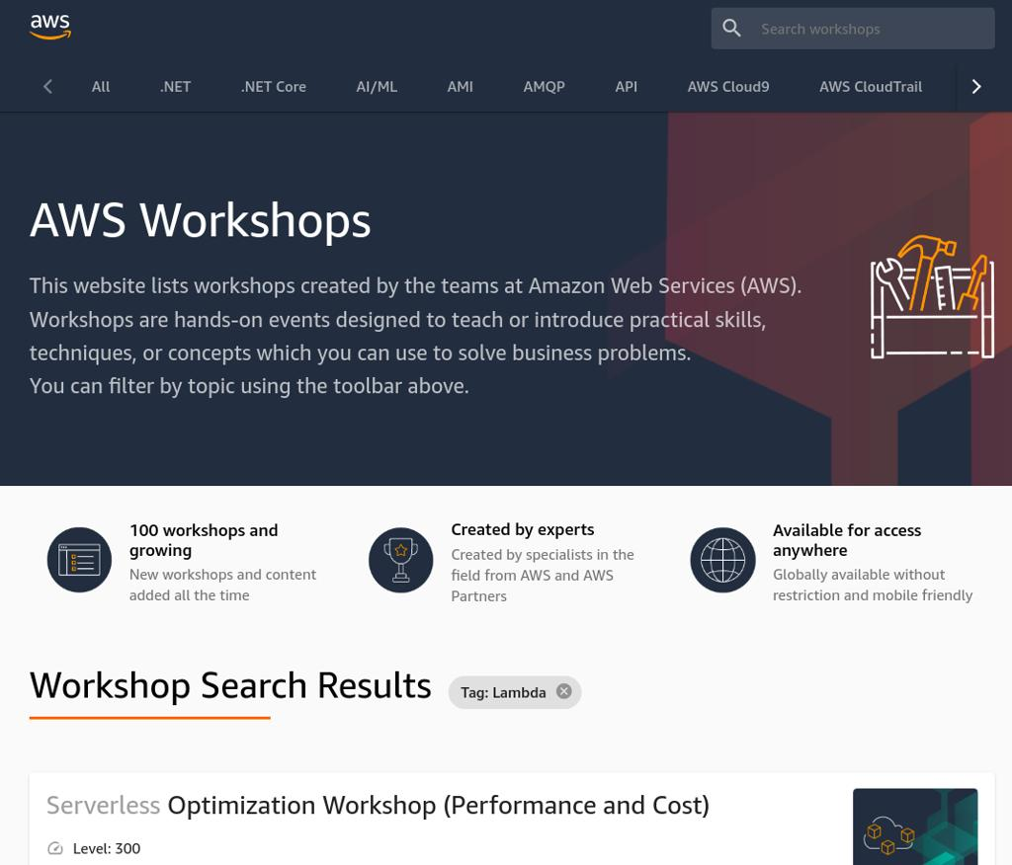

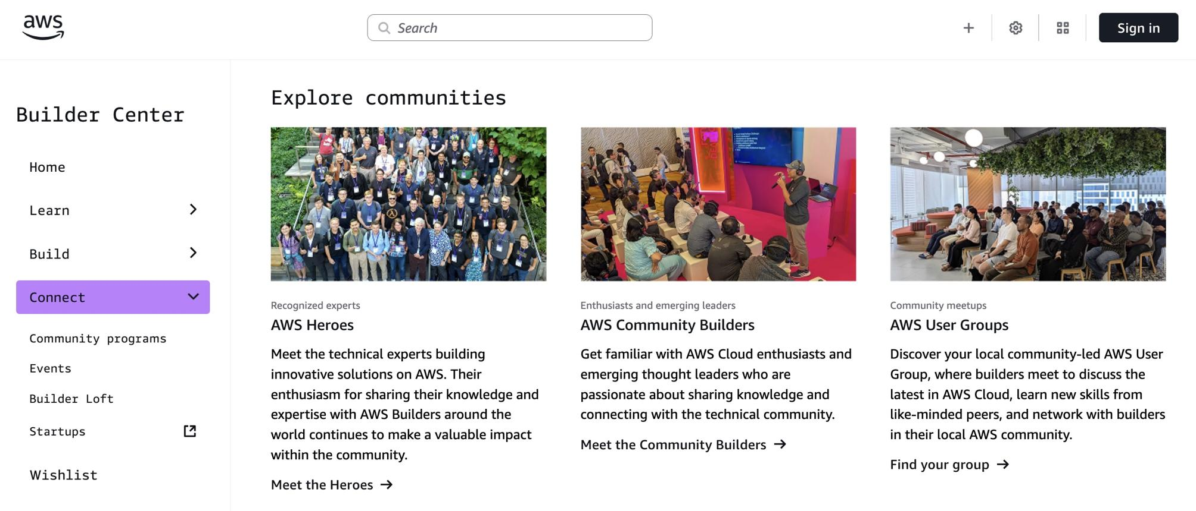

5

During the session, guide students through the following steps.

Open the Platform
Visit AWS Builder Center .

Sign In or Create an AWS Builder ID
Students can sign in using their AWS Builder ID. A Builder ID is separate from an AWS account used to operate AWS services.
Amazon Web Services, Inc.

Explore the Learn Section
Show students where they can find learning materials, training, and educational resources.

Explore Hands-On Workshops
Demonstrate how students can discover workshops and tutorials to practice cloud technologies.

Explore Community Features
Show how students can discover communities, connect with builders, and engage with technical content.

Set Up a Learning Goal
Ask every student to identify one AWS service or skill they want to explore after the workshop.

AWS IAM User Setup Guide: Granting Console Access to Explore & Manage Services

1. Service Overview & Value
- What is AWS IAM in simple terms? AWS Identity and Access Management (IAM) is like a digital identity card and keycard system for your cloud environment. It determines who can log into your AWS account (Authentication) and what services or resources they are allowed to create, view, modify, or delete (Authorization).
- Why is it helpful for a student learning cloud computing? IAM introduces the foundational cloud security principle known as Least Privilege. Instead of giving everyone the "Root" master key (which has unlimited power over billing and account settings), IAM lets you grant individual logins tailored specifically to what each person needs to learn or build.

2. Real-World Applications & Use Cases
- Common Industry Use Cases:
  - Employee Onboarding: Creating distinct logins for developers, database administrators, or financial auditors so each person only accesses their relevant workspace.
  - Automated Application Access: Generating secure access keys for web applications or CLI scripts so they can interact with cloud storage or databases automatically.
  - Multi-Factor Authentication (MFA): Enforcing extra security layers on all user logins to protect infrastructure from credential leaks.
- Real-World Scenarios:
  - Team Collaboration: A lead cloud architect creates individual IAM user profiles for team members so everyone works under their own credentials rather than sharing one password.
  - Sandbox Environments: A university professor creates isolated IAM users for students to build temporary virtual servers without giving them access to the university's main billing controls.

3. Edge Cases & Considerations
- Over-Privileging (Security Risk): Assigning full permissions (AdministratorAccess) allows a user to create or delete any resource across your entire account^{[2]}. If those credentials leak, an attacker could launch expensive resources or erase data.
- Root Account vs. IAM User: The Root User is created when you first sign up for AWS and has permanent, unrestricted access. Best practice dictates you should never use or share Root credentials for daily tasks.
- Exposing Credentials: Never post credentials or access keys in public code repositories (such as GitHub).
- Password Expiration: Enforcing a temporary password reset on first sign-in guarantees that only your friend knows their final password.

4. Prerequisites
Before you begin the hands-on setup, ensure you have:
- An active AWS Account.
- Permission to log in as an Administrator or as the Root User.
- A designated username for your friend (e.g., friend-developer).
- A secure channel (such as a password manager or encrypted messaging app) to share the sign-in link and temporary password.

5. Console Navigation
- Open your browser and navigate to the AWS Sign-In Page.
- Select Root user, enter your account email address, choose Next, and enter your password.
- On the main AWS Management Console dashboard, locate the top search bar (or press Alt + S).
- Type IAM into the search bar.
- In the search results under Services, click IAM (Manage access to AWS resources).

6. Step-by-Step Creation

Step 1: Initiate User Creation
- In the left navigation menu, click IAM Users under Access management.
- On the Users dashboard, click the orange Create user button at the top right.

Step 2: Specify User Details
- In the User name text field, enter friend-developer.
- Under AWS Management Console access, check the box Provide user access to the AWS Management Console - optional.
- Why: Your friend needs web browser access to visually explore AWS services.
- Under password, select Custom password.
- In the password text field, enter a strong temporary password.
- Keep Users must create a new password at next sign-in (recommended) checked.
- Why: This ensures your friend sets a private password that only they know as soon as they log in.
- Click the Next button at the bottom right.

Step 3: Set Permissions
- Under Permissions options, select Attach policies directly.
- Why: This allows you to pick specific permission templates directly from AWS's managed library.
- In the Permissions policies search box, type AdministratorAccess.
- Locate AdministratorAccess in the table and check the selection box next to it.
- Why: Per your goal, this policy gives your friend full permission to create, manage, and terminate services. (Note: In production environments, you would restrict permissions to specific services, but for a learning sandbox, this grants full operational freedom).
- Click Next.

Step 4: Review and Complete
- Review the User details and Permissions summary to confirm everything is accurate.
- Click Create user.

Step 5: Save & Share Sign-in Credentials
- On the confirmation screen, click Download .csv file to save the login details to your computer, or click Copy console sign-in URL.
- Securely send the Console sign-in URL, User name (friend-developer), and Temporary password to your friend.

7. Verification
To test that the new user works properly:
- Open a Private/Incognito browser window (so your main admin session isn't logged out).
- Paste the copied Console sign-in URL into the address bar and press Enter.
- Confirm that the IAM user sign-in option is selected and the Account ID field is pre-filled.
- Enter the username friend-developer and the temporary password, then click Sign in.
- Verify that AWS prompts you to enter a Old password and set a New password.
- Set a new password, complete the sign-in, and verify that you land on the AWS Management Console dashboard.

8. Clean-up (Anti-Billing)
IAM users are free of charge. However, if you want to remove access later so no unauthorized resources are created under this identity:
- Return to your main administrator browser session in the IAM Console.
- Click Users in the left navigation pane.
- Select the checkbox next to friend-developer.
- Click the Delete button at the top bar.
- In the confirmation window, type friend-developer into the text box and click Delete.

AWS S3 Tutorial: Public Data Access & Static Website Hosting

1. Service Overview & Value
- What is Amazon S3 in simple terms? Amazon Simple Storage Service (Amazon S3) is an object storage service built to store and retrieve any amount of data from anywhere on the web. Think of S3 as an infinite digital file system in the cloud where you can upload files (such as images, videos, documents, or HTML web pages) and access them via unique web addresses (URLs).
- Why is it uniquely helpful for a student learning cloud computing? S3 introduces the concept of Serverless Storage. You don't need to rent or configure virtual operating systems, manage disk drives, or install web server software (like Apache or Nginx) to serve web pages or static assets to the internet.

2. Real-World Applications & Use Cases
- Common Industry Use Cases:
  - Static Website Hosting: Hosting portfolio sites, landing pages, and documentation without managing web servers.
  - Backup & Disaster Recovery: Storing database dumps, system logs, and archival backups securely across multiple data centers.
  - Data Lakes & Analytics: Storing raw datasets that can be directly queried using SQL analytics tools like Amazon Athena^{[3]}.
- Real-World Scenarios:
  - E-Commerce Asset Delivery: Online shopping platforms store product photos and media in S3 buckets so web and mobile apps can load images quickly.
  - Digital Portfolios & Resumes: Web developers publish single-page React, Vue, or static HTML applications directly from an S3 website endpoint.

3. Edge Cases & Considerations
- Global Bucket Naming Uniqueness: S3 bucket names are globally unique across all AWS accounts worldwide. If another user owns my-web-bucket, you cannot create a bucket with that exact name.
- Default Public Access Blocking: By default, AWS blocks all public access to S3 buckets to prevent accidental data exposure. Enabling web access requires explicitly turning off Block Public Access and attaching a public Bucket Policy.
- Static vs. Dynamic Content: S3 can only host static web assets (HTML, CSS, JavaScript, images). It cannot execute server-side scripts (such as PHP, Python, or Node.js backend logic) or run relational databases directly.
- HTTP vs. HTTPS Endpoints: S3 static website endpoints only support HTTP out-of-the-box. If your application requires HTTPS or a custom domain name, AWS recommends placing Amazon CloudFront in front of your S3 bucket.

4. Prerequisites
Before starting the hands-on tutorial, ensure you have:
- An active AWS Account with access to the AWS Management Console^{[4][5]}.
- A basic HTML file saved on your computer named index.html (e.g., containing <h1>Welcome to my S3 Hosted Website!</h1>).
- An optional error HTML file named error.html (e.g., containing <h1>404 - Page Not Found</h1>).
- A globally unique bucket name ready (e.g., my-student-website-demo-2026).

5. Console Navigation
- Open your web browser and sign in to the AWS Management Console.
- Click the search bar at the top of the screen (or press Alt + S).
- Type S3 into the search box.
- Under the Services category, click S3 (Scalable Storage in the Cloud)^{[1][2]}.

6. Step-by-Step Creation

Phase A: Create the S3 Bucket
- On the S3 dashboard, click the orange Create bucket button.
- In the General configuration section:
- In the Bucket name text box, enter your globally unique bucket name (e.g., my-student-website-demo-2026).
  - Why: Bucket names become part of the web URL, so no two AWS users in the world can share the exact same bucket name.
- Under AWS Region, select the region closest to your location (e.g., Asia Pacific(Mumbai).
  - Why: Choosing a nearby region lowers latency (loading speed) for your visitors and reduces data transfer costs.
- In the Object Ownership section, leave ACLs disabled (recommended) selected.
- Why: AWS best practices recommend managing public access through centralized Bucket Policies rather than legacy Access Control Lists (ACLs).
- In the Block Public Access settings for this bucket section:
- Uncheck the box Block all public access.
  - Why: S3 blocks public access by default. Because you are hosting a public website, you must uncheck this box to allow internet visitors to read your web pages.
- Check the acknowledgement box: I acknowledge that the current settings might result in this bucket and the objects within it becoming public.
  - Why: AWS requires explicit user confirmation before allowing public visibility settings.
- Leave Bucket Versioning set to Disable and Default encryption set to Server-side encryption with Amazon S3 managed keys (SSE-S3).
- Scroll to the bottom of the page and click Create bucket.

Phase B: Upload Web Content
- In the Buckets list, click the name of your newly created bucket (my-student-website-demo-2026).
- Make sure you are on the Objects tab.
- Click the Upload button.
- Click Add files and select your local index.html (and error.html) file(s), or drag and drop them into the upload box.
- Scroll down and click the orange Upload button.
- Once you see the green Upload succeeded banner, click Close.

Phase C: Enable Static Website Hosting
- Click the Properties tab near the top of your bucket interface.
- Scroll down to the very bottom section titled Static website hosting.
- Click Edit.
- Under Static website hosting, select Enable.
- Under Hosting type, ensure Host a static website is selected.
- In the Index document field, type index.html.
- Why: This tells S3 which file to serve automatically when a visitor navigates to your root website URL.
- In the Error document - optional field, type error.html (or index.html).
- Click Save changes.

Phase D: Configure Public Read Permissions (Bucket Policy)
- Click the Permissions tab near the top of your bucket interface.
- Scroll down to the Bucket policy section and click Edit.
- In the Policy text editor, paste the following JSON policy (replace YOUR-BUCKET-NAME with your actual bucket name):
{
"Version": "2012-10-17",
"Statement": [
{
"Sid": "PublicReadGetObject",
"Effect": "Allow",
"Principal": "*",
"Action": "s3:GetObject",
"Resource": "arn:aws:s3:::YOUR-BUCKET-NAME/*"
}
]
}

- Why: This policy explicitly grants anyone on the web (Principal: *) permission to read (s3:GetObject) all files (/*) in this specific bucket (YOUR-BUCKET-NAME).
- Click Save changes.

7. Verification
- Click the Properties tab of your bucket.
- Scroll down to the Static website hosting section at the bottom.
- Under Bucket website endpoint, copy the generated URL (e.g., http://my-student-website-demo-2026.s3-website-us-east-1.amazonaws.com).
- Open an Incognito / Private browser window.
- Paste the endpoint URL into the address bar and press Enter.
- Expected Result: Your index.html web page should load successfully in the browser window.

8. Clean-up (Anti-Billing)
To avoid potential storage charges when you are finished testing:
- Navigate to the Objects tab in your bucket (my-student-website-demo-2026).
- Select all uploaded files using the checkbox at the top of the object table.
- Click Delete.
- In the confirmation field, type permanently delete and click Delete objects.
- Click Close to return to the main S3 dashboard.
- Select the checkbox next to your empty bucket (my-student-website-demo-2026) and click Delete from the top menu.
- In the confirmation box, type the exact name of your bucket and click Delete bucket.

AWS EC2 Tutorial: Launching Linux, Installing Nginx, & Deploying a React App

1. Service Overview & Value
- What is Amazon EC2 in simple terms? Amazon Elastic Compute Cloud (Amazon EC2) is essentially a virtual computer in the cloud. Instead of buying physical server hardware, EC2 allows you to rent virtual servers (called "instances") with your choice of operating system (such as Amazon Linux or Ubuntu), CPU, RAM, and storage.
- Why is it uniquely helpful for a student learning cloud computing? EC2 provides complete root/administrator access to an operating system running in AWS data centers. It allows students to gain hands-on experience with Linux administration, web server configuration (Nginx/Apache), networking (Security Groups), and application deployment.

2. Real-World Applications & Use Cases
- Common Industry Use Cases:
  - Web & Application Hosting: Hosting backend APIs (Node.js, Python, Java) and frontend web applications.
  - Batch & Background Processing: Running background worker tasks, queue processors, or automated data extraction jobs.
  - Development & Testing Environments: Spin up temporary development environments that mirror production setups.
- Real-World Scenarios:
  - E-Commerce Web Servers: Retail companies host dynamic web applications on EC2 instances behind load balancers to scale up during sales events like Black Friday.
  - SaaS Platforms: Startups run microservices inside Linux EC2 instances, serving thousands of user requests daily.

3. Edge Cases & Considerations
- Security Group Inbound Rules: By default, new EC2 instances block all incoming internet traffic except SSH (Port 22). If you forget to open HTTP (Port 80) in the Security Group, web browsers will time out when trying to view your React app.
- Elastic IP vs. Dynamic Public IP: Stopping and starting an EC2 instance changes its Public IP address. If you reboot your server, the IP address used to view your application will change unless an Elastic IP is attached.
- State Retention / Data Persistence: Storage attached to an EC2 instance (EBS volume) persists when stopped, but if you Terminate the instance, the server and its local files are permanently deleted.
- Single Page Application (SPA) Routing with Nginx: React uses client-side routing. Without proper Nginx configuration (try_files $uri $uri/ /index.html;), refreshing a sub-page (e.g., /dashboard) will result in a 404 Not Found error from Nginx.

4. Prerequisites
Before starting the tutorial, ensure you have:
- An active AWS Account.
- Access to the AWS Management Console.
- A SSH terminal tool (e.g., Terminal on Mac/Linux, PowerShell/Git Bash on Windows) OR use AWS's web-based EC2 Instance Connect.

5. Console Navigation
- Open your browser and log into the AWS Management Console.
- Click the top search bar (or press Alt + S).
- Type EC2 into the search bar.
- Under Services, click EC2 (Virtual Servers in the Cloud).

6. Step-by-Step Creation & Deployment

Phase A: Launching the EC2 Instance
- On the EC2 Dashboard, click the orange Launch instance button.
- Under Name and tags:
- In the Name text field, type react-web-server.
- Under Application and OS Images (Amazon Machine Image):
- Select Ubuntu.
- Under Instance type:
- Select t2.micro (or t3.micro depending on region).
  - Why: t2.micro provides 1 vCPU and 1 GiB RAM, which is eligible for the AWS Free Tier.
- Under Key pair (login):
- Click Create new key pair.
- In Key pair name, type ec2-react-key.
- Keep Key pair type as RSA and Private key file format as .pem.
- Click Create key pair. (A .pem file will automatically download to your computer. Store this safely!)
- Under Network settings:
- Click Edit on the right side.
- Ensure Auto-assign public IP is set to Enable.
- Under Firewall (security groups), choose Create security group.
- Set Security group name to react-server-sg.
- Add the following Inbound security group rules:
  - Rule 1 (SSH): Type: SSH | Port: 22 | Source type: My IP (Why: Restricts administrative terminal access strictly to your current connection for security).
  - Click Add security group rule.
  - Rule 2 (HTTP): Type: HTTP | Port: 80 | Source type: Anywhere (0.0.0.0/0) (Why: Opens web traffic on Port 80 so anyone on the internet can load your web application).
- Under Configure storage:
- Leave default at 8 GiB gp3 General Purpose SSD.
- Scroll down and click the orange Launch instance button.
- Click View all instances at the bottom right.

Phase B: Connecting to Your Instance
- In the Instances list, select the checkbox next to react-web-server.
- Wait until the Instance state shows Running and Status check shows 3/3 checks passed.
- Click the Connect button at the top bar.
- Select the EC2 Instance Connect tab.
- Keep the default username as ec2-user.
- Click Connect. (A browser-based Linux terminal window will open).

Phase C: Installing Node.js, Git, & Nginx
Step 1: Update the System
Log into your EC2 instance via SSH and update the core system packages to ensure compatibility.
bash
sudo apt update && sudo apt upgrade -y

Step 2: Install Node.js and npm
Install Node.js (version 20) along with its package manager, npm.
bash
# Download and setup the NodeSource repository
curl -fsSL https://deb.nodesource.com/setup_20.x | sudo -E bash -

# Install Node.js
sudo apt install -y nodejs
sudo apt install npm
(Optional) You can verify the installation by checking the versions:
bash
node -v # Output should be v20.x.x
npm -v # Output should be 10.x.x

Step 3: Clone the Repository
Install Git, download the source code from GitHub, and navigate directly into the project folder.
bash
# Install Git
sudo apt install -y git

# Clone the repository
git clone https://github.com/kanaka2001/AIML-workshop.git

# Move into the portfolio application folder
cd AIML-workshop/react-web-portal

Step 4: Install Dependencies and Build the App
Download all required third-party libraries and execute the build script to generate production-ready assets.
bash
# Install package dependencies allowing execution scripts
npm install --allow-scripts

# Compile the application (generates a /dist folder)
npm run build

Step 5: Install Nginx and Deploy Files
Install the Nginx web server, transfer your compiled files to its root directory, and launch the service.
bash
# Install Nginx web server
sudo apt install -y nginx

# Copy all static files from the dist/ folder to Nginx's default web directory
sudo cp -r dist/* /var/www/html/

# Start Nginx and ensure it launches automatically on system boots
sudo systemctl start nginx
sudo systemctl enable nginx

Step 6: Verify the Live Deployment
Your React site is now live. Open a web browser window and navigate to your public AWS address:
text
http://<your-ec2-public-ip>

(Press Ctrl + O , hit Enter to save, then press Ctrl + X to exit).
- Test and reload Nginx:
sudo nginx -t
sudo systemctl reload nginx

7. Verification
- Go back to the AWS Management Console &gt; EC2 &gt; Instances.
- Click on your react-web-server instance.
- In the instance details pane below, copy the Public IPv4 address (e.g., 54.210.12.34).
- Open a new tab in your web browser.
- Enter `http://

AWS Bedrock Guide: Model Access & Playground Exploration

1. Service Overview & Value
- What is Amazon Bedrock in simple terms? Amazon Bedrock is a fully managed AWS service that offers access to leading Generative AI "Foundation Models" (FMs) through a single unified interface^{[1]}. Think of Bedrock as a digital app store and testing lab for artificial intelligence. Instead of training your own massive AI model from scratch or managing complex GPU server infrastructure, Bedrock lets you connect to top-tier models from AI research organizations (such as Anthropic, Meta, Mistral AI, Cohere, and Amazon) on demand^{[1]}.
- Why is it uniquely helpful for a student learning cloud computing? Bedrock provides a serverless, zero-infrastructure path to experimenting with state-of-the-art Generative AI. As a student, you don't need to rent expensive GPU virtual machines or write complex machine learning pipelines. You can test prompts, evaluate different AI models side-by-side, adjust AI behavioral parameters (like creativity and response length), and integrate generative AI into your applications using simple API calls.

2. Real-World Applications & Use Cases
- Common Industry Use Cases:
  - Enterprise Chatbots & Assistants: Powering customer support agents that read company documentation and answer user questions in natural language.
  - Text Summarization & Generation: Automatically generating executive summaries of long PDF reports, generating marketing copy, or translating documents across languages.
  - Code Generation & Refactoring: Assisting software engineers by generating boilerplate code, identifying bugs, or writing unit tests.
- Real-World Scenarios:
  - E-Commerce Product Assistant: A retail platform uses Bedrock to power a conversational shopping assistant that helps customers find products based on natural language queries like "Find me a waterproof hiking jacket under $100."
  - Healthcare Clinical Summarization: Medical administrative systems use Bedrock models to convert unstructured doctor notes into structured medical summaries safely within private cloud boundaries.

3. Edge Cases & Considerations
- AWS Region Availability: Foundation models are not distributed identically across all AWS Regions. Some models (such as Anthropic Claude 3.5 Sonnet) may only be available in specific primary regions like us-east-1 (N. Virginia) or us-west-2 (Oregon). Always verify your console region before requesting access.
- Anthropic Use Case Form Requirement: To access Anthropic models (like Claude), AWS requires a one-time submission of "Use Case Details" (company description, intended use, and website URL). As a student, you can enter your personal portfolio URL or university web page.
- Serverless Pay-Per-Token Billing: Bedrock's playgrounds operate on a serverless, pay-per-token model. Every prompt you send (input tokens) and every response generated (output tokens) incurs a tiny fraction-of-a-cent charge.
- Non-Deterministic Outputs: Generative AI models generate text probabilistically. Sending the exact same prompt twice may yield slightly different wording unless your Temperature parameter is set to 0.
- Provisioned Throughput vs. Serverless: For standard playground testing, use default serverless inference. Avoid purchasing Provisioned Throughput, which reserves dedicated capacity for thousands of dollars per month!

4. Prerequisites
Before beginning the hands-on setup, ensure you have:
- An active AWS Account with access to the AWS Management Console^{[2]}.
- An IAM User or Role with permissions to access Amazon Bedrock (e.g., AmazonBedrockFullAccess).
- An active browser session set to an AWS Region supporting Bedrock foundation models (recommended: us-east-1 or us-west-2).

5. Console Navigation
- Open your browser and navigate to the AWS Sign-In Page^{[3]}.
- Log in using your root user credentials or IAM user credentials.
- On the main AWS Management Console landing screen, locate the top search bar (or press Alt + S)^{[2]}.
- Type Bedrock into the search bar.
- In the search results under Services, click Amazon Bedrock (Access best-in-class foundation models)^{[1]}.
- In the top-right corner of the console screen, click the Region selector dropdown and ensure US East (N. Virginia) us-east-1 or US West (Oregon) us-west-2 is selected.

6. Step-by-Step Creation & Exploration

Exploring & Testing in the Chat Playground
- In the left navigation menu under the Playgrounds section, click Chat.
- At the top left of the main playground window, click the Select model button.
- In the Select model modal window:
- Under Category / Provider, choose Anthropic (or Amazon).
- Under Model, select Claude 3.5 Sonnet (or Titan Text G1 - Express).
- Click Apply.
- In the right-hand Configurations side panel, locate the inference parameters:
- Temperature: Slide or set to 0.7.
  - Why: Temperature controls creativity. 0.0 makes responses rigid and deterministic; 1.0 makes outputs highly creative. 0.7 is a balanced setting for general tasks.
- Top P (Nucleus Sampling): Leave at default 0.9.
  - Why: Top P cuts off low-probability token predictions to prevent nonsensical text.
- Maximum length / Max tokens: Set to 1024.
  - Why: Limits the maximum response length to prevent runaway costs or endless generation.
- In the System prompt text box at the top of the playground, enter: You are an expert AWS Cloud Architect tutor. Explain cloud concepts clearly with helpful analogies.
- Why: System prompts establish the role, tone, constraints, and personality of the AI model before the conversation starts.
- Click into the bottom user input box (User field), type: What is the difference between Amazon S3 and Amazon EC2?
- Click the Run button (or press Shift + Enter).
- Watch as the AI model streams its response directly into the main conversation chat window.

7. Verification
- Review the generated text response in the Chat Playground main window.
- At the bottom of the AI model's response bubble, inspect the token metrics:
- Confirm that Input tokens, Output tokens, and Latency (ms) are displayed.
- Test a different model provider to compare outputs:
- Click Select model at the top bar.
- Switch the provider to Meta and choose Llama 3 Instruct, then click Apply.
- Re-run the same question and observe how the response style, speed, and token counts differ.

8. Clean-up (Anti-Billing)
Amazon Bedrock playgrounds operate strictly on a serverless pay-per-token model. When you stop interacting with the playground, generation stops immediately, and no background server charges accumulate.
To ensure you incur zero ongoing costs:
- Simply close the Chat Playground browser tab when finished.
- In the left navigation menu under Provisioned Throughput, verify that you have 0 active provisioned throughput allocations. (Provisioned throughput is an advanced feature that charges hourly rates for dedicated throughput—do NOT create one for learning/testing!)
- If you created any custom IAM policies specifically for this testing session that you no longer need, you can delete them in the IAM Console

AWS SageMaker Canvas Tutorial: No-Code Machine Learning & Predictive Analytics

1. Service Overview & Value
- What is Amazon SageMaker Canvas in simple terms? Amazon SageMaker Canvas is a visual, point-and-click, no-code machine learning (ML) and Generative AI tool. It allows business analysts, students, and domain experts to build accurate ML models and generate predictions using tabular data, images, text, or foundation models without writing a single line of code.
- Why is it uniquely helpful for a student learning cloud computing? SageMaker Canvas bridges the gap between raw data and artificial intelligence. You do not need a background in Python, algorithms, or complex data science math. It automates the entire machine learning pipeline—data preparation, feature engineering, model selection, hyperparameter tuning, and deployment—giving you immediate, hands-on experience with real-world ML workflows.

2. Real-World Applications & Use Cases
- Common Industry Use Cases:
  - Customer Churn Prediction: Identifying which subscribers or users are at risk of cancelling their service so companies can offer proactive retention incentives.
  - Demand & Financial Forecasting: Predicting future product sales, stock inventory levels, or revenue trends based on historical time-series data.
  - Fraud & Risk Detection: Flagging suspicious credit card transactions or fraudulent account applications before approving them.
- Real-World Scenarios:
  - E-Commerce Customer Retention: A marketing team uploads historical store purchase data to Canvas, selects "Customer Status" (Stayed vs. Cancelled) as the target, and receives predictions on which active users might leave next month.
  - Healthcare Readmission Analytics: A hospital administrator uses patient demographic and treatment data in Canvas to predict which patients have a high risk of readmission within 30 days.

3. Edge Cases & Considerations
- Data Quality Matters ("Garbage In, Garbage Out"): SageMaker Canvas automates model building, but it cannot fix fundamentally flawed or heavily biased data. Your dataset must contain a clear, relevant column you want to predict (the target variable) along with descriptive features.
- Training Time vs. Cost (Quick Build vs. Standard Build):
  - Quick Build: Builds a prototype model in 2–15 minutes for rapid testing.
  - Standard Build: Runs full AutoML hyperparameter optimization across multiple model types (takes 15–90+ minutes), providing higher accuracy but consuming more workspace session time.
- Canvas App Workspace Hours: SageMaker Canvas charges an hourly rate for active user workspace sessions. Closing the browser tab does not log you out of the background session—you must explicitly click Sign out inside Canvas to stop billing.
- Imbalanced Datasets: If predicting a rare event (e.g., fraud occurring in 0.1% of transactions), overall "Accuracy" can be misleading. Canvas provides advanced metrics like Precision, Recall, and F1 Score to evaluate true predictive performance.

4. Prerequisites
Before beginning the hands-on tutorial, ensure you have:
- An active AWS Account with permissions to access Amazon SageMaker.
- An active SageMaker Domain and User Profile (or permission to create a single-user quick setup domain).
- A sample tabular dataset in .csv format (for this tutorial: a Customer Churn CSV file with columns such as Account_Length, Monthly_Charges, Cust_Service_Calls, and a binary target column like Churn).

5. Console Navigation
- Open your web browser and sign in to the AWS Management Console.
- Click the top search bar (or press Alt + S).
- Type SageMaker into the search box.
- Under Services, click Amazon SageMaker AI (Build, train, and deploy machine learning models at scale).
- In the left navigation menu under Applications, click Canvas (or navigate to Domains &gt; select your domain > select your User Profile &gt; click Launch &gt; Canvas).

6. Step-by-Step Creation: Customer Churn Model

Step 1: Launch the SageMaker Canvas Application
- On the SageMaker console landing page, click Canvas under the left Applications menu.
- Under User profiles, locate your profile name and click the Open Canvas button on the right.
- Wait 1–3 minutes while AWS provisions your dedicated no-code workspace.

Step 2: Import Your Dataset
- In the left navigation menu of the Canvas workspace, click the My models icon (or Datasets icon).
- Click the orange New model button at the top right.
- In the Model name text box, type Customer-Churn-Predictor.
- Under Problem type, keep Predictive analysis selected, then click Create.
- On the Select dataset tab, click Import data.
- Select Upload (or select Amazon S3 if your file is already stored in a bucket).
- Drag and drop your churn.csv file into the file drop area, then click Import dataset.

Step 3: Select Target Variable & Prepare Data
- Select the checkbox next to your imported churn.csv dataset and click Select dataset.
- In the Build tab, locate the Target column dropdown menu on the right panel.
- Select Churn (or Leave) as your target variable.
- Why: Canvas will analyze all other columns in your dataset to figure out which factors predict whether Churn is "True" or "False".
- Observe that Canvas automatically detects the problem type as Two-category prediction (Binary Classification).

Step 4: Build and Train the Model
- Click Validate data to confirm there are no missing values or formatting errors in your columns.
- Click the Quick build button at the bottom right.
- Why: Quick build constructs a functional prototype model in under 10 minutes so you can evaluate initial accuracy without waiting for a full AutoML tuning cycle.
- Wait while Canvas performs data transformation, feature selection, and algorithm training.

7. Verification
- Once model training completes, Canvas automatically navigates to the Analyze tab.
- Inspect the Overview metrics:
- Verify the Model predict accuracy percentage (e.g., 94.2%).
- Review the Column impact (Feature Importance) waterfall chart:
- Identify which factors contributed most to customer churn (e.g., Cust_Service_Calls or Monthly_Charges).
- Click the Predict button at the bottom right:
- Select Single prediction to test individual customer scenarios manually by adjusting column sliders.
- Select Batch prediction to upload a new CSV file of current active customers and generate churn probability scores for all of them at once.

8. Clean-up (Anti-Billing)
SageMaker Canvas charges for workspace session hours when running. To safely shut down your workspace and prevent background charges:
- In the bottom-left corner of the SageMaker Canvas workspace UI, click the Account / Log out icon.
- Click Sign out to terminate the active Canvas application instance.
- Return to the main AWS Management Console &gt; SageMaker &gt; Domains.
- Click on your Domain name, select your User Profile, and verify that the app state for Canvas displays Stopped.
- (Optional) If you created a temporary SageMaker Domain solely for this lab, click Delete user profile and then Delete domain.

PartyRock is a browser-based, code-free Generative AI playground powered by Amazon Bedrock (https://partyrock.aws/). It allows anyone—students, educators, analysts, and developers—to experiment with prompt engineering and build multi-widget AI applications without needing an AWS account or writing a single line of code.
Key themes I noticed across the sources:
- Zero AWS Account or Setup Required: Anyone can log in using Google, Apple, or Amazon credentials with free daily usage and no credit card needed.
- Visual Block/Widget Builder: You build apps by connecting modular widgets such as User Input, Text Generation, Image Generation, Chatbot, and Data Analysis Agents.
- Prompt Chaining & Model Freedom: Outputs from one widget can be referenced as variables in another (@WidgetName), allowing you to chain prompts together while selecting underlying foundation models from providers like Anthropic (Claude), Meta (Llama), and Amazon (Titan).
- Instant Sharing & App Remixing: Apps can be published via a public URL, allowing others to test them or "remix" them to customize the design and prompts further.
📥 The full research report is included as the first source in the import card below — import it to chat with the findings directly and save them to your notebook.

Official AWS certifications validate cloud expertise to help professionals highlight in-demand skills and demonstrate technical capability to organizations^{[1]}. The sources outline several official certification tracks organized across different experience levels^{[1]}:

Official AWS Certification Tracks
- Foundational Level: Designed to validate overall cloud understanding^{[2]}.
  - AWS Certified Cloud Practitioner (CLF-C02): Validates overall foundational knowledge of the AWS Cloud across job roles^{[2]}.
  - AWS Certified AI Practitioner (AIF-C01): Validates foundational understanding of AI, machine learning, and generative AI concepts and use cases for business professionals^{[2]}.
- Associate Level: Designed for technical roles in architecture, development, and engineering^{[1][3]}.
  - AWS Certified Solutions Architect - Associate (SAA-C03): Validates technical skills in designing distributed systems using the AWS Well-Architected Framework^{[3]}.
  - AWS Certified Machine Learning Engineer - Associate (MLA-C02): Validates skills to implement, deploy, and maintain AI/ML solutions^{[3]}.
  - AWS Certified Developer - Associate: Validates technical development skills on AWS^{[1]}.
- Professional Level: Intended for candidates with two or more years of hands-on experience performing complex tasks^{[4]}.
  - AWS Certified Solutions Architect - Professional (SAP-C02): Validates advanced expertise in designing distributed applications and systems at scale^{[4]}.
  - AWS Certified DevOps Engineer - Professional (DOP-C02): Validates technical skills in provisioning, operating, and managing distributed application systems^{[4]}.
  - AWS Certified Generative AI Developer - Professional (AIP-C01): Validates advanced technical skills in designing, implementing, and deploying AI solutions^{[4]}.
- Specialty Level: Focused on deep expertise in specific technical domains^{[5]}.
  - AWS Certified Security - Specialty (SCS-C03): Validates expertise in securing AWS workloads, data classifications, and protection mechanisms^{[5]}.
  - AWS Certified Advanced Networking - Specialty (ANS-C01): Validates skills in designing and implementing AWS and hybrid IT network architectures at scale^{[5]}.

Preparation Resources
Official preparation resources provided by AWS include Exam Prep on AWS Skill Builder, official exam guides, policies, FAQs, and hands-on tutorials^{[6][7]}.

What Is Missing in the Sources
While the sources note that certifications help highlight in-demand skills^{[1]}, they do not detail specific resume impact metrics (such as salary benchmarks or hiring statistics) or pathways to earn exam vouchers and certifications for free.

